**VIVEKANANDA INSTITUTE OF PROFESSIONAL STUDIES – TC**

**School of Engineering & Technology**

**LAB MANUAL**

**SUBJECT NAME: Computer Networks and Internet Protocols**

**COURSE CODE: AIDS256**

**SEMESTER: 4th**

**FACULTY TEACHING COURSE: Dr. Vishal Srivastava, Dr. Safina Shokeen, Dr. Nisha Chugh**

**CHECKED BY: Dr. Vishal**

**Lab Incharge**

**_____________________**

**HEAD OF DEPARTMENT**

**INDEX**

|  |  |  |
| --- | --- | --- |
| **S No.** | **Contents** | **Page No.** |
| 1. | List of Experiments with CO and BL mapping as per the Course Syllabus | 3 |
| 2. | Detailed explanation of all the experiments with outputs/observations. (Atleast five Geo Tag photographs of the labs taken by the faculty) | 4-34 |
| 3 | (i) Internal Practical Exam Notice | 34 |
| (ii) Geo Tag Photographs on the day of Internal Practical conducted |
| 4. | Continuous Evaluation (40 marks) | 35-41 |

1. **List of Experiments with CO and BL mapping**

|  |  |  |  |
| --- | --- | --- | --- |
| S. No | List of Experiments | Course Outcome Mapping | Blooms Level |
| 1. | Introduction to basic networking tools: Wireshark and Network Miner. | [1] | [2] |
| 2. | Introduction to Datadog tool for data monitoring in network. | [1] | [2] |
| 3. | Running and using services/commands like ping, trace, route, nslookup, arp, ftp etc. | [1,2] | [3] |
| 4. | Introduction to Network Bandwidth analyser tool for network monitoring. | [2] | [2] |
| 5. | Implementation of Packet Capture and observations using packet Sniffer. | [1, 2] | [3] |
| 6. | Tracing DNS with Wireshark. | [1, 2] | [4] |
| 7. | Analyzing various parameters for TCP protocol in action. | [1, 2] | [4] |
| 8. | Create Ring, Bus, Star and Mesh topology using Cisco Packet Tracer. | [2] | [6] |
| 9. | Configure a network using distance vector routing and link state vector routing protocol. | [2] | [6] |
| 10. | Implement Dijkstra’s shortest path algorithm in network routing. | [1,2] | [4] |

1. **Detailed explanation of all the experiments with outputs/observations**

**Lab Manual**

**COMPUTER NETWORK INTERNET PROTOCOL LAB**

**AIDS 256**



**Second Year, 4th Semester**

22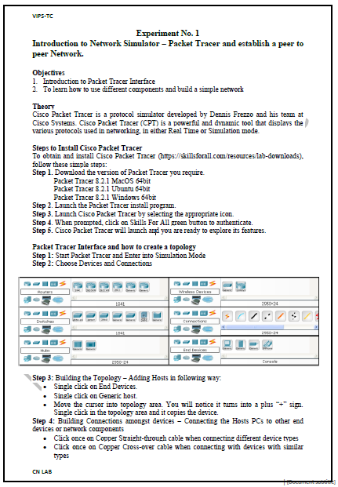 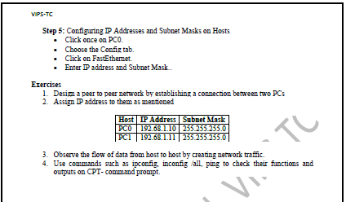

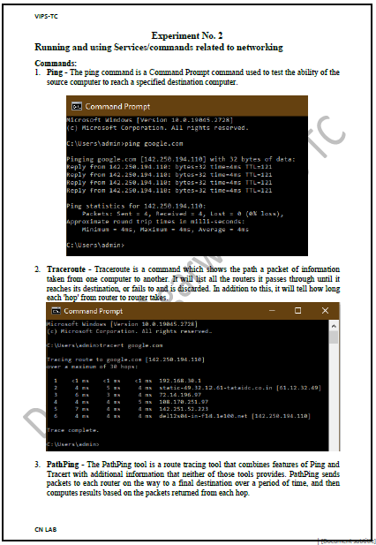 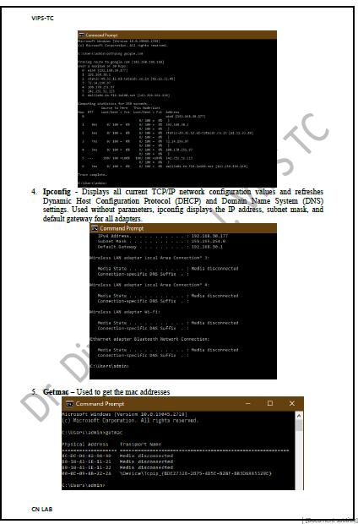 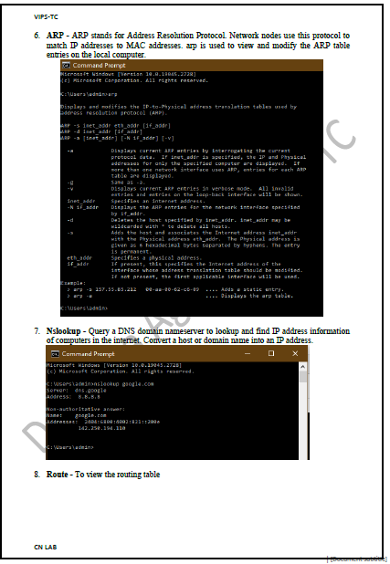 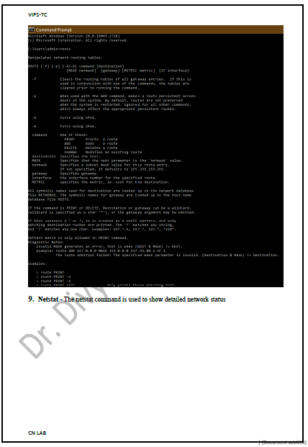 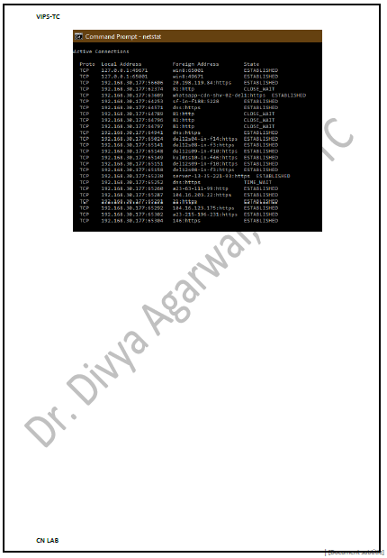 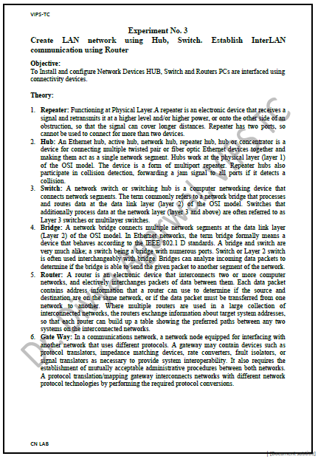 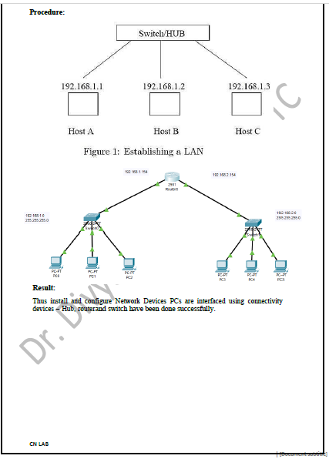 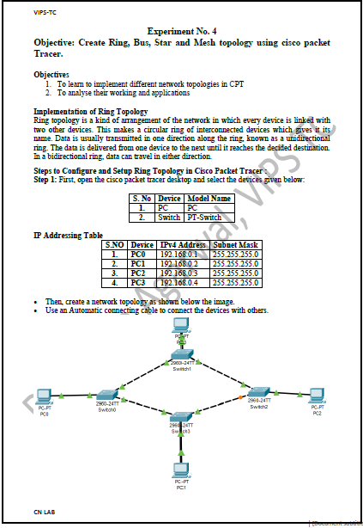 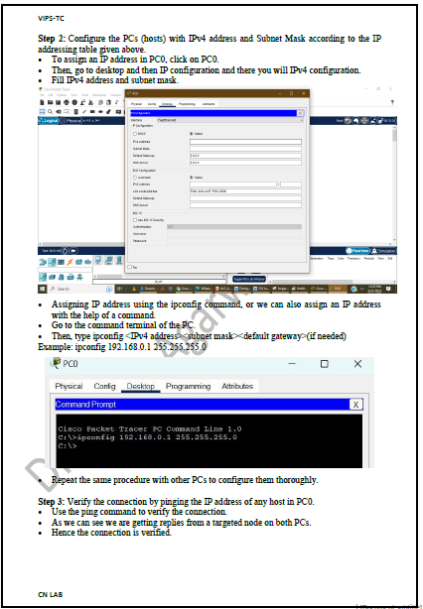 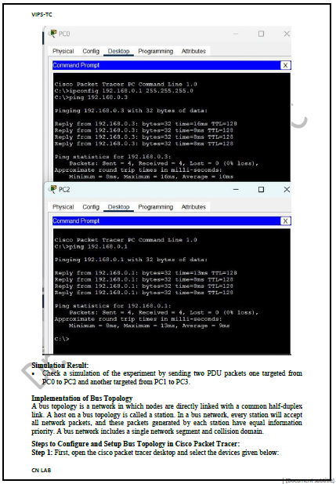 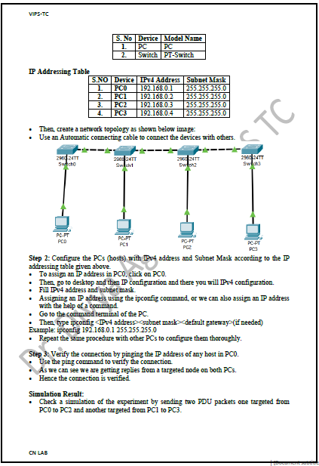 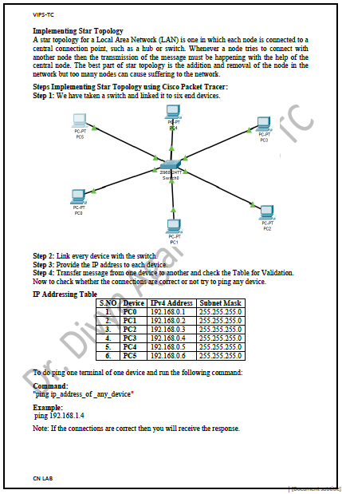 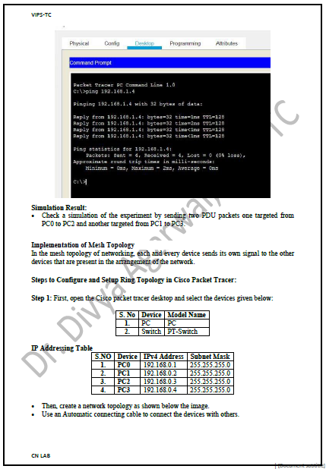 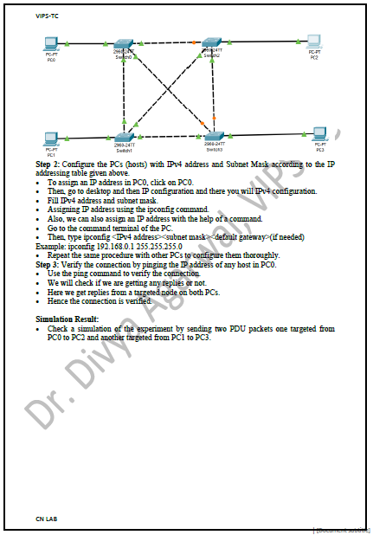 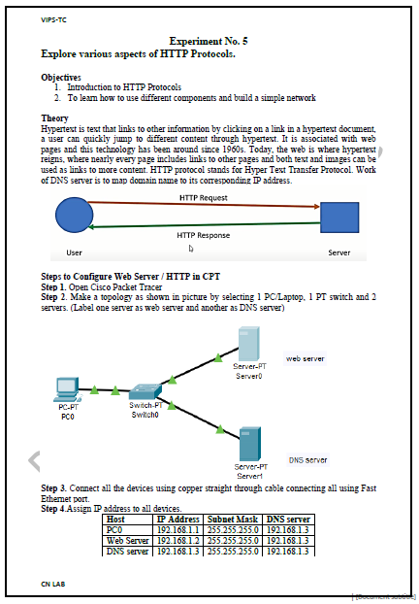 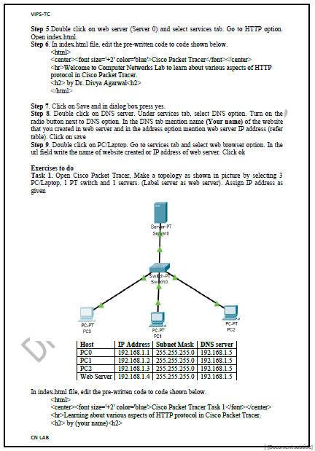 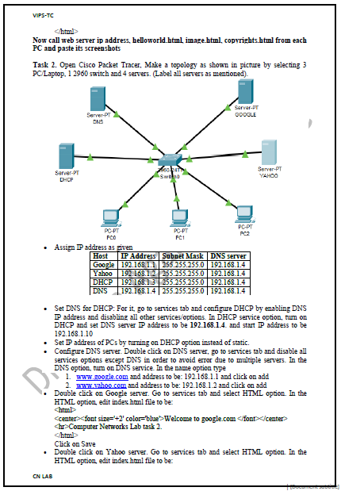 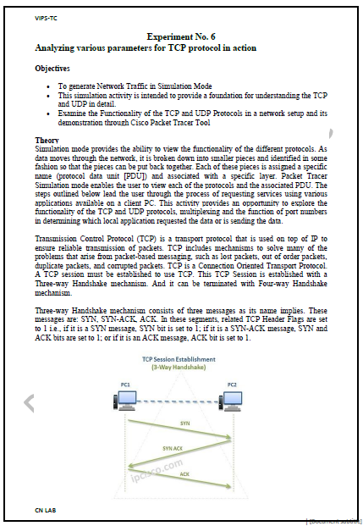 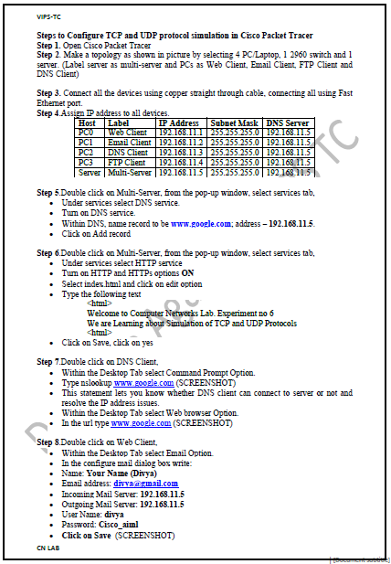 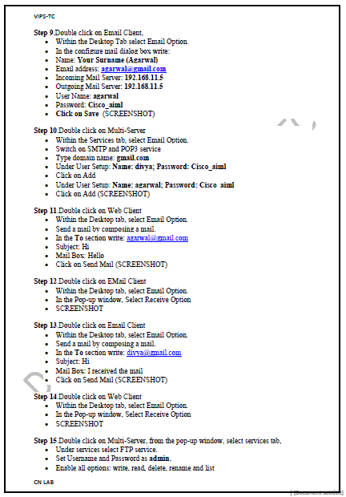 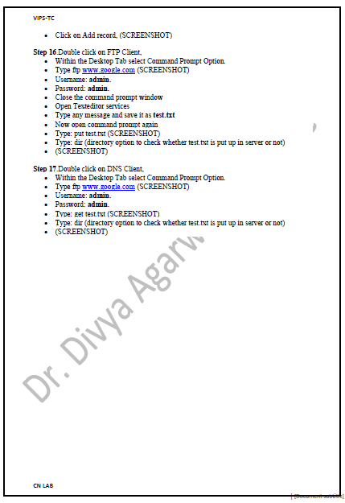 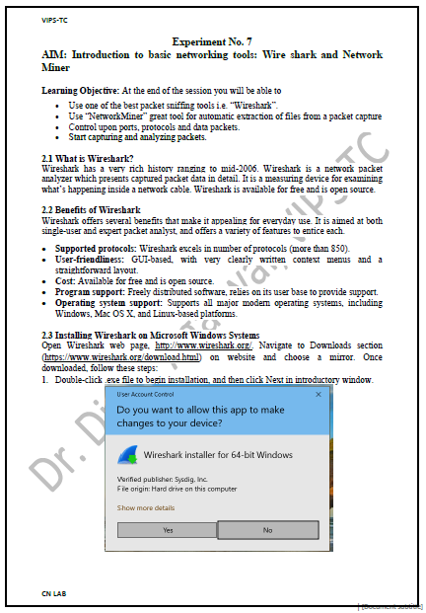 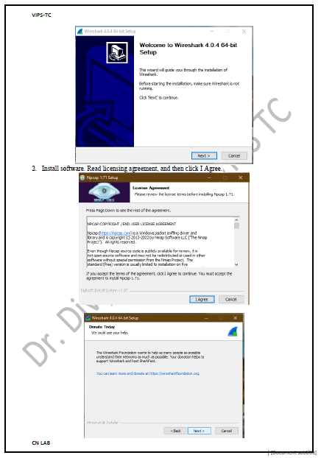 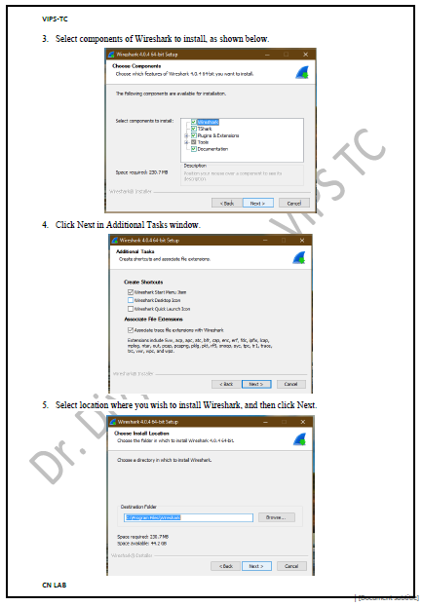 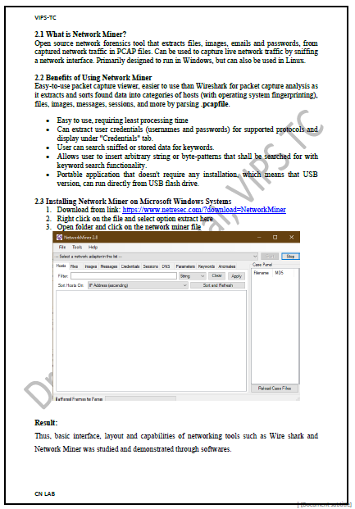 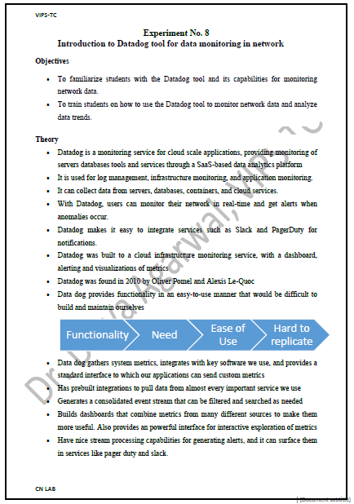 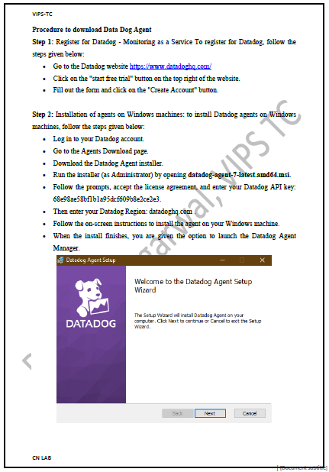 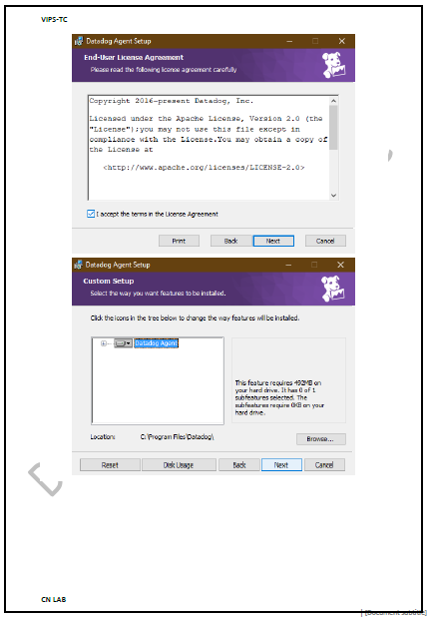 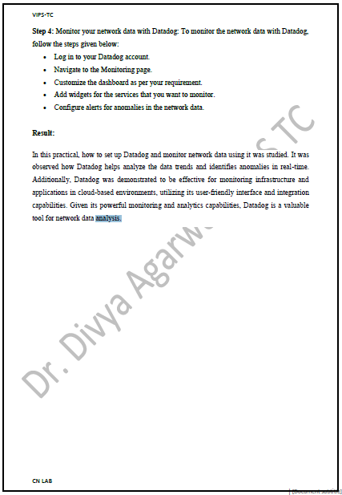

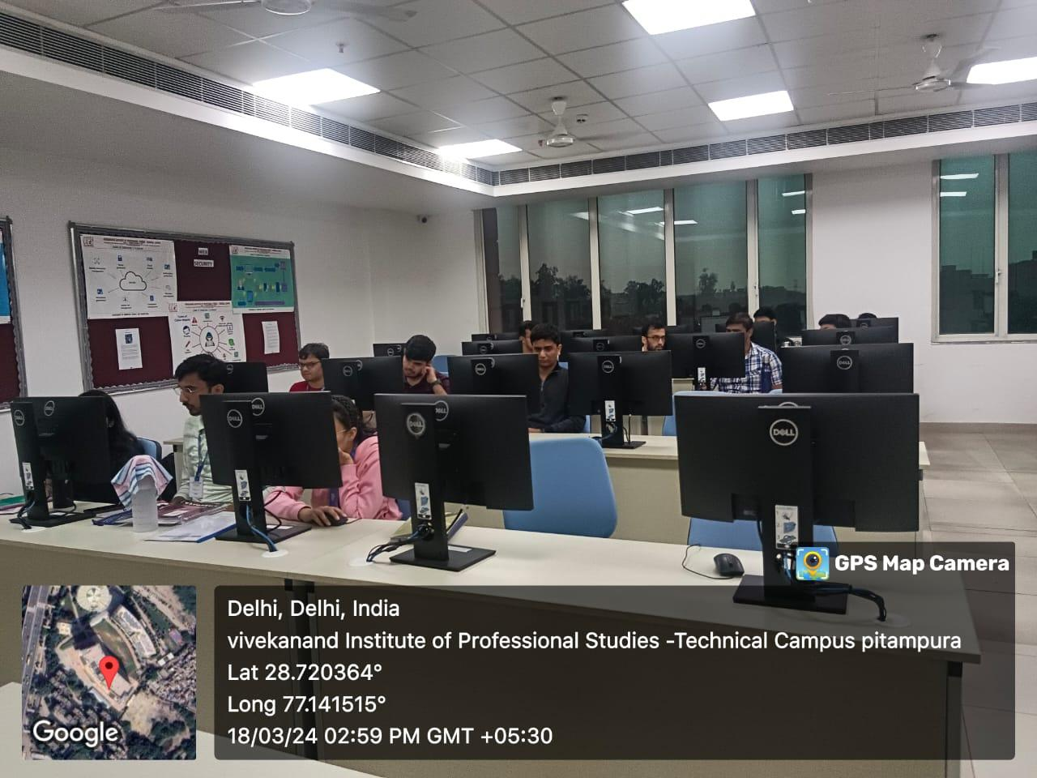

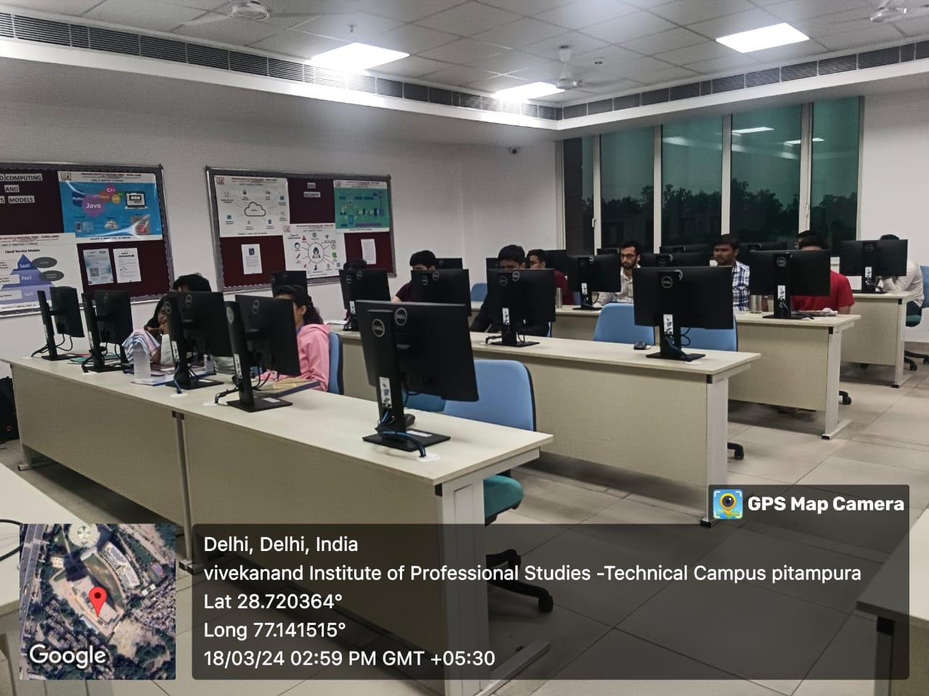

1. **(i) Internal Practical Exam Notice**

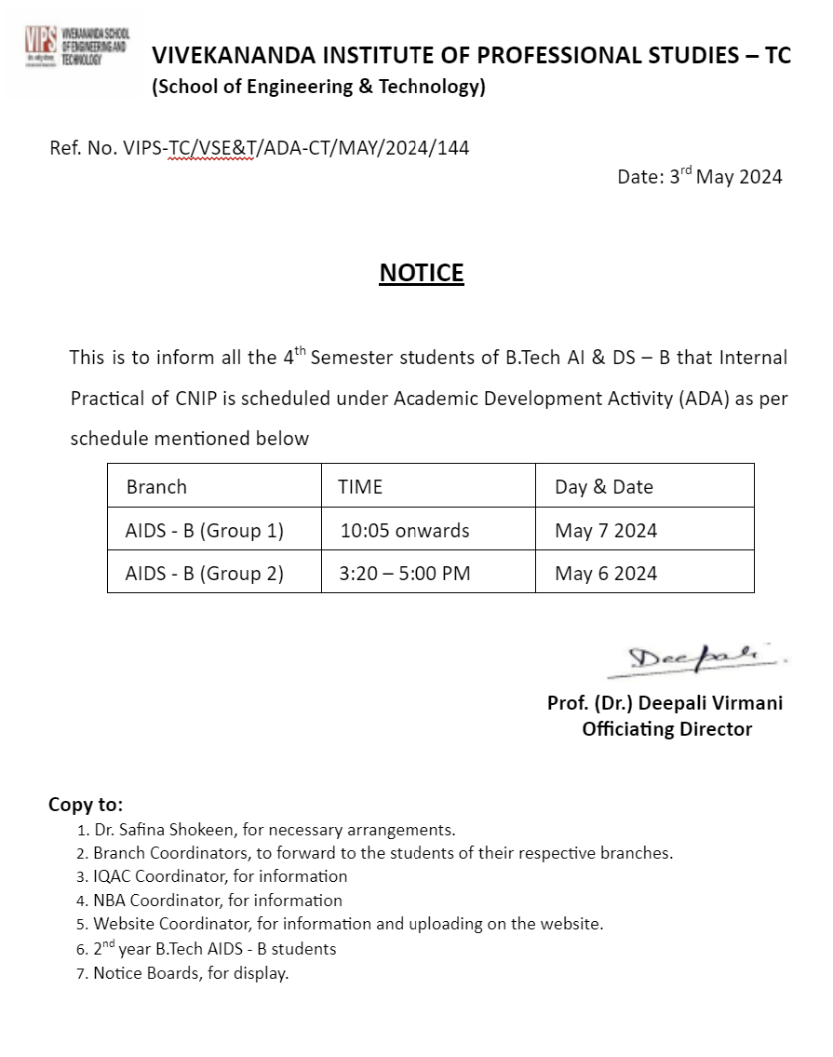

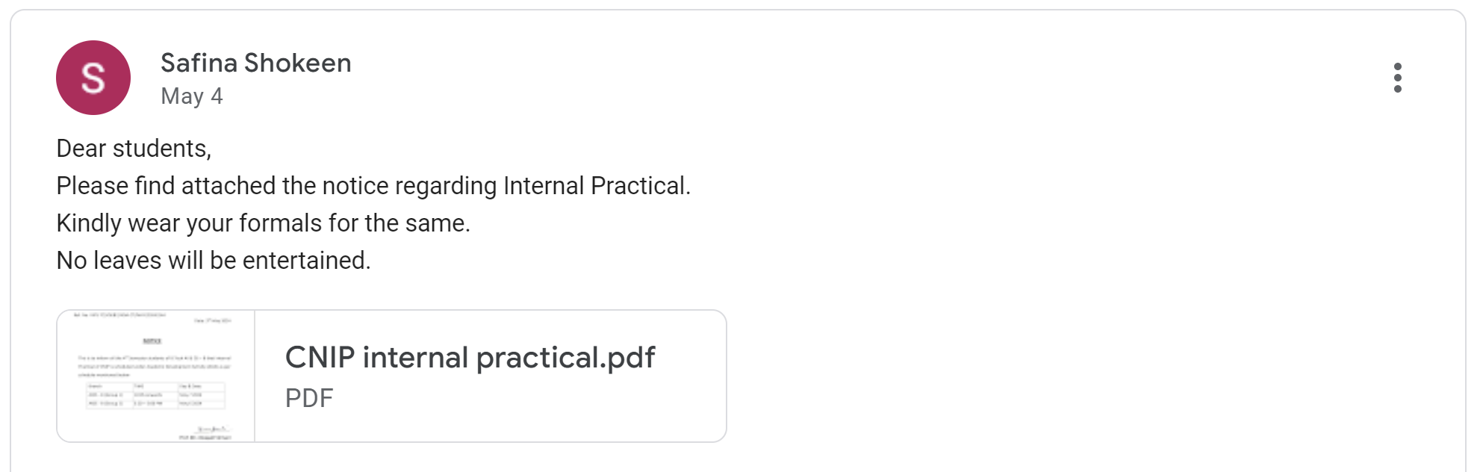

**(ii) Geo Tag Photographs on the day of Internal Practical conducted**

* **AIDS (A)**

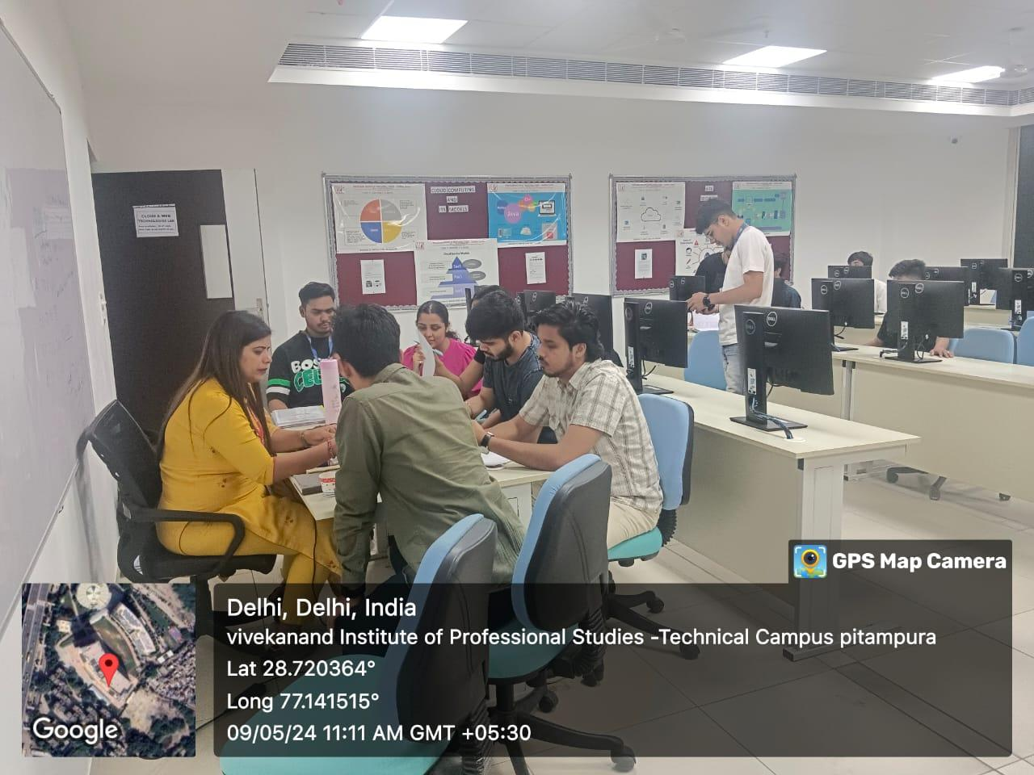

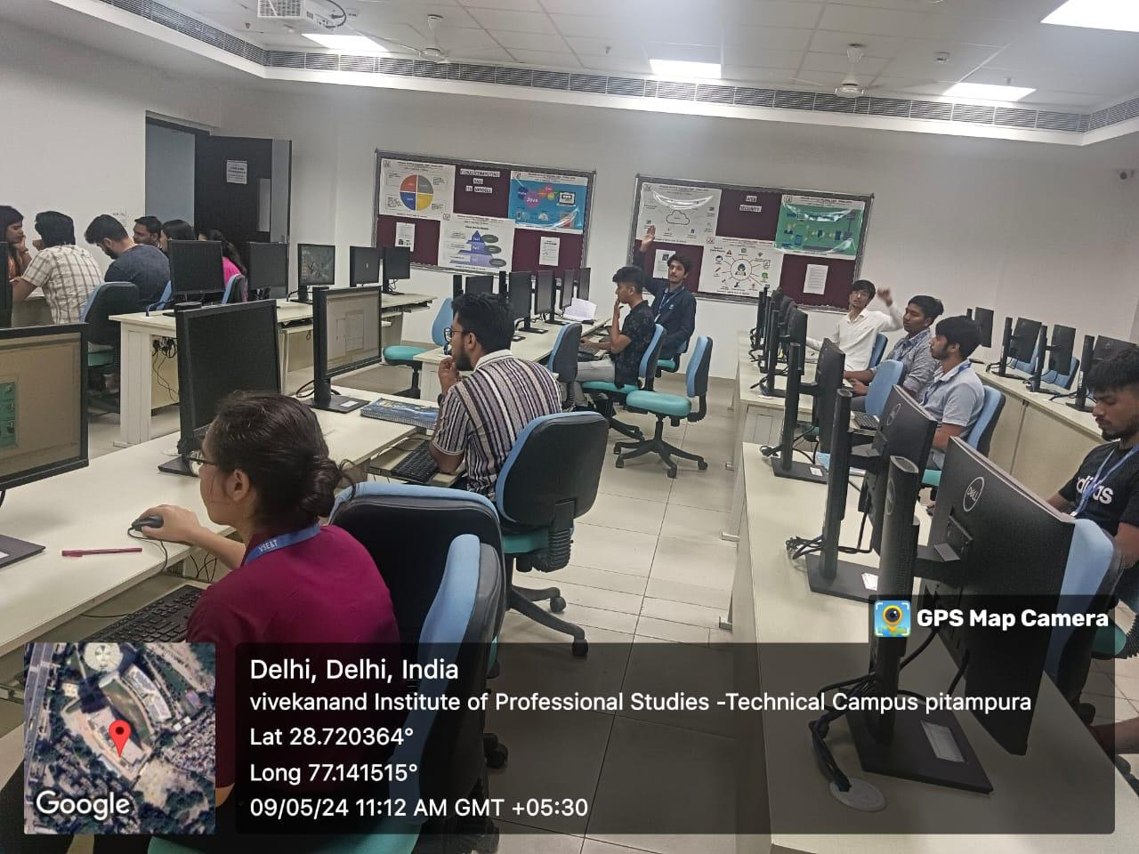

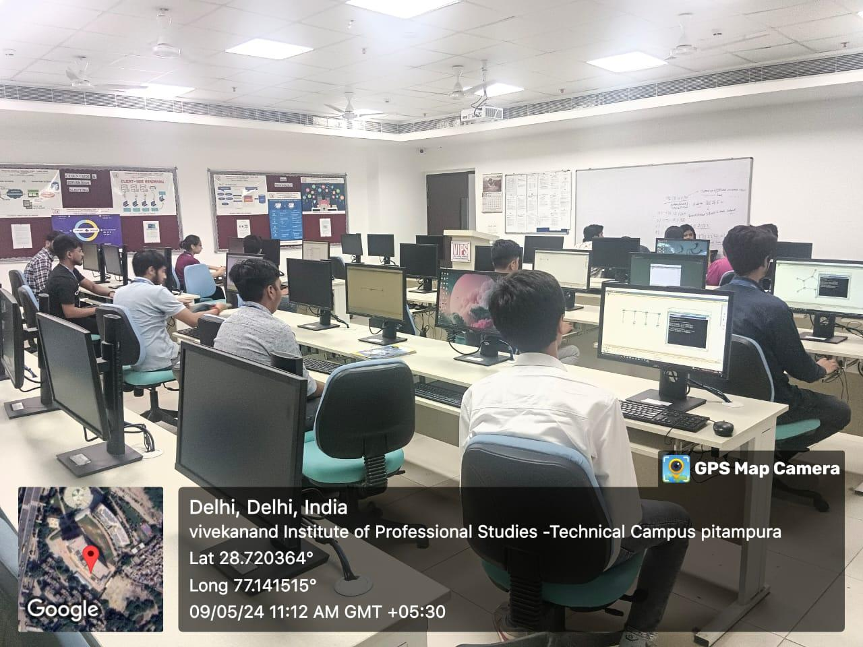

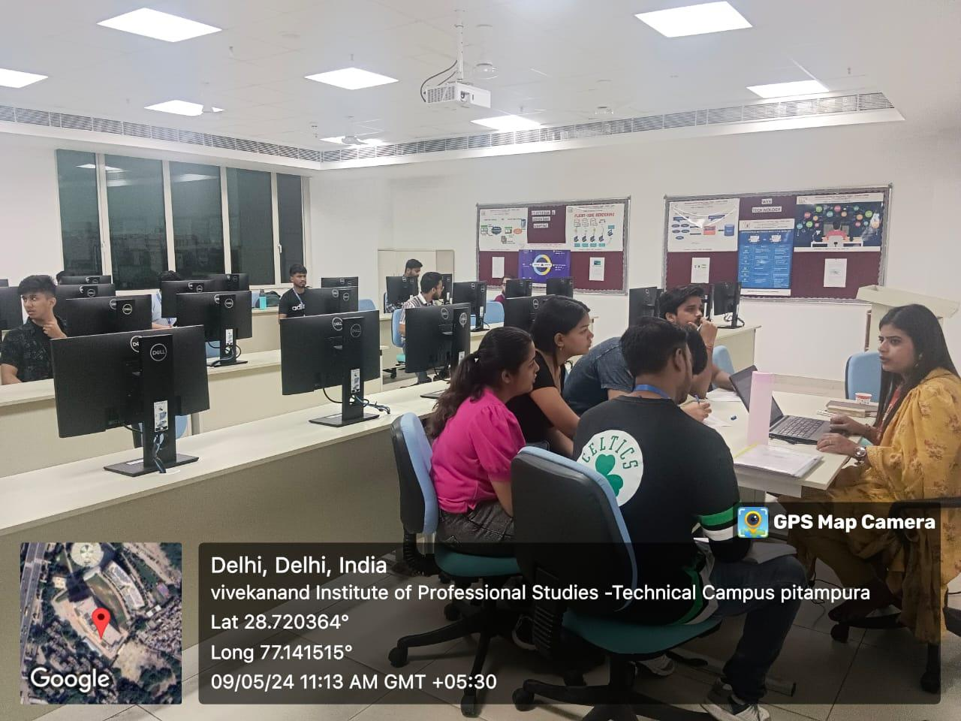

* **AIDS (B)**

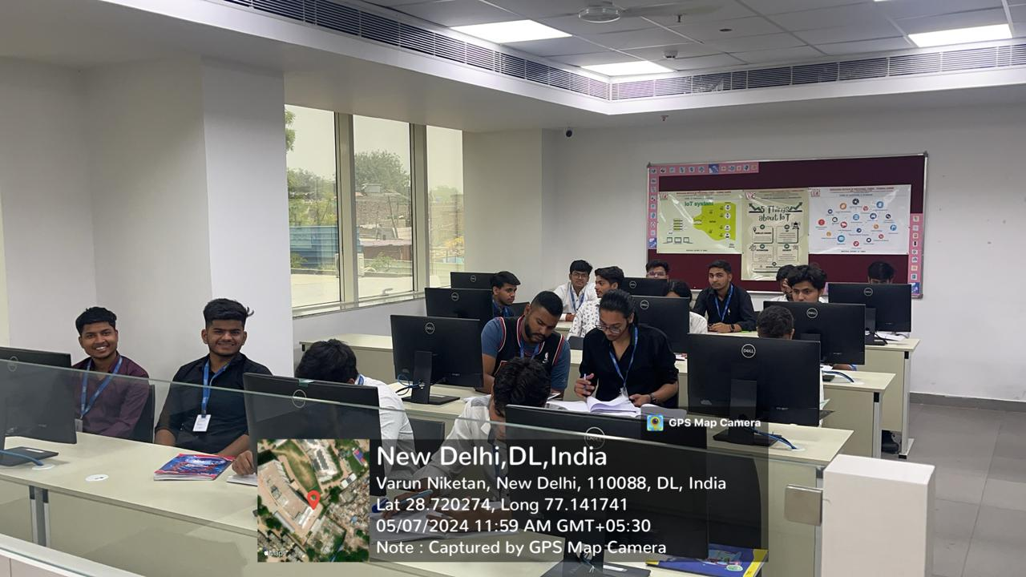

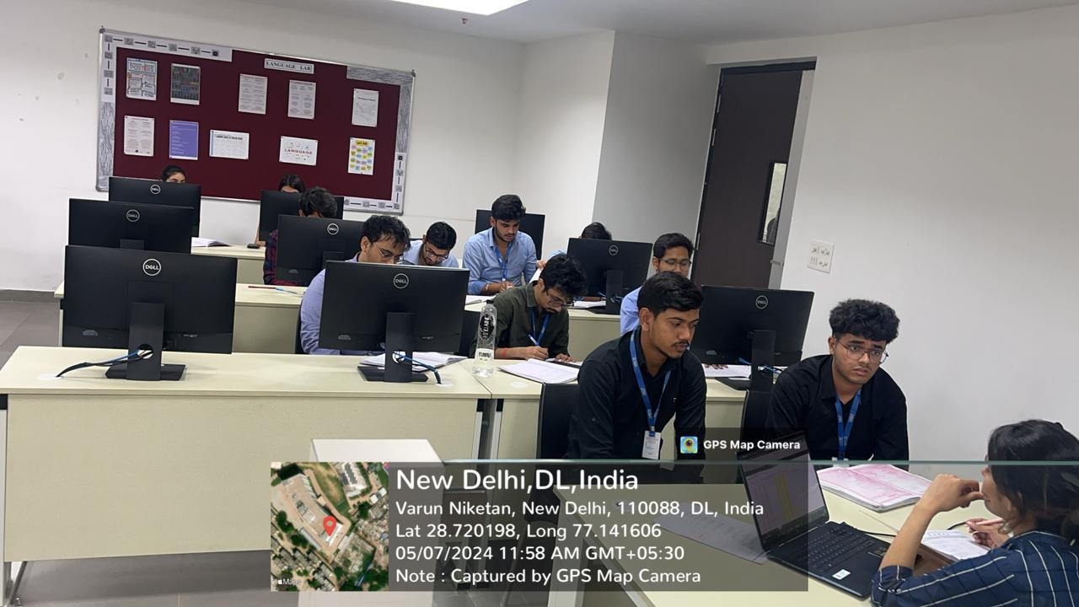

1. **Continuous Evaluation (40 marks)**

* **AIML-A**

|  |  |  |  |  |  |  |  |  |
| --- | --- | --- | --- | --- | --- | --- | --- | --- |
| **Artificial Intelligence & Machine Learning - Section A (2022-26)** | | | | | | | | |
| **SL. NO.** | **EnrollmentNo** | **Name** | **Group** | **File (15)** | **Viva (10)** | **Perform (10)** | **Attandance (5)** | **Total (40)** |
| 1 | 01317711622 | Lakshay Sharma | Group 1 | 14 | 9 | 9 | 5 | 37 |
| 2 | 01417711622 | Sankalp Mathur | Group 1 | 13 | 7 | 9 | 4 | 33 |
| 3 | 01517711622 | Sanya Behera | Group 1 | 14 | 9 | 9 | 5 | 37 |
| 4 | 01617711622 | Ishan Sharma | Group 1 | 14 | 9 | 9 | 5 | 37 |
| 5 | 01717711622 | Sunaina | Group 1 | 12 | 6 | 8 | 4 | 30 |
| 6 | 01817711622 | VAIBHAV SACHDEVA | Group 1 | 12 | 6 | 8 | 4 | 30 |
| 7 | 01917711622 | Anshul Bansal | Group 1 | 12 | 8 | 9 | 4 | 33 |
| 8 | 02017711622 | Ayush | Group 1 | 14 | 9 | 9 | 5 | 37 |
| 9 | 02117711622 | HARSHIT RAO | Group 1 | 12 | 8 | 8 | 4 | 32 |
| 10 | 02217711622 | Manas Gupta | Group 1 | 13 | 8 | 9 | 5 | 35 |
| 11 | 02317711622 | SIAN BHUTANI | Group 1 |  |  |  |  | 0 |
| 12 | 02417711622 | Urvashi sharma | Group 1 | 12 | 8 | 8 | 3 | 31 |
| 13 | 02517711622 | Dhruv Gola | Group 1 | 12 | 7 | 7 | 3 | 29 |
| 14 | 02617711622 | Ananya Swami | Group 1 | 14 | 9 | 9 | 5 | 37 |
| 15 | 02717711622 | SOUMIL SURI | Group 1 | 13 | 7 | 8 | 4 | 32 |
| 16 | 02817711622 | AARISH JAIN | Group 1 | 10 | 6 | 7 | 3 | 27 |
| 17 | 02917711622 | Utsav Singhal | Group 1 | 15 | 9 | 10 | 5 | 39 |
| 18 | 03017711622 | Mansha Malhotra | Group 1 | 11 | 7 | 7 | 3 | 28 |
| 19 | 03117711622 | NIKIL | Group 1 | 10 | 7 | 7 | 2 | 26 |
| 20 | 03217711622 | adamya gupta | Group 1 | 10 | 7 | 7 | 2 | 26 |
| 21 | 03317711622 | KOMAL PARASHAR | Group 1 | 12 | 8 | 8 | 3 | 31 |
| 22 | 20517711622 | Ritwik Arora | Group 1 | 12 | 7 | 8 | 5 | 32 |
| 23 | 03517711622 | Ayush Kumar Singh | Group 1 | 8 | 6 | 6 | 1 | 21 |
| 24 | 03617711622 | Himnish Ahuja | Group 1 |  |  |  |  | 0 |
| 25 | 03717711622 | Arth Popli | Group 1 | 8 | 7 | 6 | 1 | 22 |
| 26 | 03917711622 | Saarthak Bansal | Group 1 | 13 | 7 | 8 | 4 | 32 |
| 27 | 04017711622 | Raunit Arora | Group 1 | 13 | 8 | 8 | 5 | 34 |
| 28 | 04117711622 | SNEHA BHASIN | Group 1 | 13 | 8 | 8 | 4 | 33 |
| 29 | 04217711622 | Aryan Raj | Group 2 | 11 | 7 | 7 | 3 | 28 |
| 30 | 04317711622 | Dhruv Kataria | Group 2 | 9 | 8 | 6 | 2 | 25 |
| 31 | 04417711622 | RACHIT RAWAL | Group 2 | 11 | 6 | 7 | 3 | 27 |
| 32 | 04517711622 | Khushboo Chopra | Group 2 | 10 | 6 | 6 | 2 | 24 |
| 33 | 04617711622 | Prabhnoor Singh | Group 2 | 10 | 7 | 6 | 2 | 25 |
| 34 | 04717711622 | Ayush Khurana | Group 2 | 9 | 7 | 6 | 1 | 23 |
| 35 | 04817711622 | Saral Mishra | Group 2 | 9 | 6 | 6 | 1 | 22 |
| 36 | 04917711622 | Priyanshu Pandey | Group 2 | 10 | 9 | 7 | 3 | 29 |
| 37 | 05017711622 | ROHAN SINGH BISHT | Group 2 | 12 | 8 | 8 | 4 | 32 |
| 38 | 05117711622 | sanjana sharma | Group 2 | 12 | 8 | 8 | 5 | 33 |
| 39 | 05217711622 | sambhav saini | Group 2 | 11 | 8 | 6 | 3 | 28 |
| 40 | 05317711622 | Rahul goel | Group 2 |  |  |  |  | 0 |
| 41 | 05417711622 | Dilpreet singh | Group 2 | 9 | 8 | 5 | 1 | 23 |
| 42 | 05517711622 | Anmol Gulati | Group 2 | 12 | 7 | 7 | 3 | 29 |
| 43 | 05617711622 | MEHAK | Group 2 |  |  |  |  | 0 |
| 44 | 05717711622 | Akshat Singh | Group 2 | 12 | 8 | 8 | 3 | 31 |
| 45 | 05817711622 | Chakshu Gupta | Group 2 | 13 | 8 | 8 | 4 | 33 |
| 46 | 06017711622 | Naman Mudgal | Group 2 | 12 | 8 | 8 | 3 | 31 |
| 47 | 06117711622 | Dhairya Goel | Group 2 | 14 | 9 | 9 | 5 | 37 |
| 48 | 06217711622 | Kunal Bansal | Group 2 | 14 | 9 | 9 | 5 | 37 |
| 49 | 06317711622 | Peeyush | Group 2 | 14 | 8 | 9 | 5 | 36 |
| 50 | 06417711622 | Sagar Singh | Group 2 | 9 | 9 | 7 | 1 | 26 |
| 51 | 06517711622 | Pankaj Negi | Group 2 | 11 | 8 | 7 | 2 | 28 |
| 52 | 06617711622 | Pratham Jindal | Group 2 | 13 | 9 | 7 | 3 | 32 |
| 53 | 06717711622 | AARYAN SHARMA | Group 2 | 10 | 8 | 7 | 2 | 27 |
| 54 | 06817711622 | Achintya Bansal | Group 2 | 12 | 9 | 8 | 3 | 32 |
| 55 | 06917711622 | Anshika Goyal | Group 2 | 12 | 8 | 7 | 3 | 30 |
| 56 | 07017711622 | Raunak Negi | Group 2 | 11 | 7 | 6 | 1 | 25 |
| 57 | 07117711622 | Ansh Chawla | Group 2 | 14 | 8 | 9 | 4 | 35 |
| 58 | 00117708523 | MD FAIZAL | Group 2 | 12 | 7 | 8 | 3 | 30 |
| 59 | 00217708523 | AYUSH KUMAR | Group 2 | 14 | 8 | 8 | 5 | 35 |
| 60 | 00317708523 | VIKAS SINGH | Group 2 | 12 | 7 | 7 | 2 | 28 |
| 61 | 00517708523 | Amit kumar | Group 2 | 14 | 8 | 9 | 5 | 36 |
| 62 | 00617708523 | Arpit Rewliya | Group 2 | 9 | 7 | 6 | 1 | 23 |

* **AIML-B**

|  |  |  |  |  |  |  |  |  |
| --- | --- | --- | --- | --- | --- | --- | --- | --- |
| **Artificial Intelligence & Machine Learning - Section B (2022-26)** | | | | | | | | |
| **SL. NO.** | **EnrollmentNo** | **Name** | **Group** | **File (15)** | **Viva (10)** | **Perform (10)** | **Attandance (5)** | **Total (40)** |
| 1 | 07217711622 | suryanshi chadha | Group 1 | 13 | 8 | 8 | 3 | 32 |
| 2 | 07417711622 | SARTHAK GOEL | Group 1 | 8 | 7 | 7 | 1 | 23 |
| 3 | 07517711622 | Aksh | Group 1 | 11 | 7 | 9 | 3 | 30 |
| 4 | 07617711622 | Rakshit vashist | Group 1 | 13 | 8 | 9 | 2 | 32 |
| 5 | 07717711622 | Roshan | Group 1 | 13 | 10 | 10 | 3 | 36 |
| 6 | 07817711622 | Khushi sharma | Group 1 | 12 | 8 | 10 | 2 | 32 |
| 7 | 07917711622 | ROHIT SAH | Group 1 | 14 | 8 | 10 | 3 | 35 |
| 8 | 08017711622 | Krishna Beernally | Group 1 | 15 | 9 | 10 | 5 | 39 |
| 9 | 08117711622 | arnav | Group 1 | 9 | 6 | 6 | 1 | 22 |
| 10 | 08217711622 | Utkarsh Negi | Group 1 | 11 | 8 | 8 | 3 | 30 |
| 11 | 08317711622 | Aanya Jain | Group 1 | 12 | 8 | 10 | 3 | 33 |
| 12 | 08417711622 | KRISHNA ROHILLA | Group 1 | 12 | 8 | 10 | 3 | 33 |
| 13 | 08517711622 | Riya Sharma | Group 1 | 15 | 10 | 10 | 3 | 38 |
| 14 | 08617711622 | Jayant | Group 1 | 7 | 7 | 7 | 1 | 22 |
| 15 | 08717711622 | Prakash Kumar | Group 1 | 12 | 8 | 10 | 2 | 32 |
| 16 | 08817711622 | Himanshu | Group 1 |  |  |  | 0 | 0 |
| 17 | 08917711622 | Dev Garg | Group 1 |  |  |  | 1 | 1 |
| 18 | 09017711622 | Ayush Chauhan | Group 1 | 11 | 7 | 10 | 3 | 31 |
| 19 | 09117711622 | Aditya Kumar | Group 1 |  |  |  | 0 | 0 |
| 20 | 09217711622 | ADITYA VASHSIHT | Group 1 | 10 | 7 | 7 | 2 | 26 |
| 21 | 09317711622 | Yogesh kumar | Group 1 |  |  |  | 0 | 0 |
| 22 | 09417711622 | ANUJ KUMAR | Group 1 |  |  |  | 0 | 0 |
| 23 | 09517711622 | Rishi Gupta | Group 1 | 13 | 9 | 10 | 5 | 37 |
| 24 | 09617711622 | Pradaksh Prasun | Group 1 | 11 | 7 | 9 | 5 | 32 |
| 25 | 09717711622 | Pranav Kumar | Group 1 | 11 | 10 | 9 | 3 | 33 |
| 26 | 09817711622 | AADITYA SHARMA | Group 1 | 13 | 8 | 9 | 3 | 33 |
| 27 | 09917711622 | Harshit Maurya | Group 1 | 13 | 8 | 10 | 3 | 34 |
| 28 | 10017711622 | vishal kumar | Group 1 | 14 | 10 | 10 | 5 | 39 |
| 29 | 10117711622 | NILAKSHI | Group 1 | 14 | 9 | 10 | 5 | 38 |
| 30 | 10217711622 | Disha Gusain | Group 1 | 11 | 9 | 10 | 3 | 33 |
| 31 | 10317711622 | Vishesh Aggarwal | Group 2 | 14 | 9 | 10 | 5 | 38 |
| 32 | 10417711622 | keshav kabra | Group 2 | 12 | 8 | 10 | 4 | 34 |
| 33 | 10517711622 | Akash Kumar | Group 2 |  |  |  |  |  |
| 34 | 10617711622 | Divyansh tyagi | Group 2 | 11 | 8 | 10 | 3 | 32 |
| 35 | 10717711622 | Nandani Daga | Group 2 | 15 | 9 | 10 | 5 | 39 |
| 36 | 10817711622 | Yash Sharma | Group 2 | 11 | 7 | 10 | 3 | 31 |
| 37 | 10917711622 | Akarshan Nagpal | Group 2 | 10 | 6 | 8 | 2 | 26 |
| 38 | 11017711622 | Yuvraj Singh Shekhawat | Group 2 | 12 | 7 | 8 | 2 | 29 |
| 39 | 11117711622 | saurav kumar | Group 2 | 10 | 7 | 7 | 2 | 26 |
| 40 | 11217711622 | Tanishq Rawat | Group 2 | 14 | 7 | 9 | 4 | 34 |
| 41 | 11417711622 | avinash kumar | Group 2 |  |  |  |  | 0 |
| 42 | 11517711622 | Namit Bhardwaj | Group 2 |  |  |  |  | 0 |
| 43 | 11617711622 | aryan malik | Group 2 |  |  |  |  | 0 |
| 44 | 35117711622 | Devansh Bhasin | Group 2 |  |  |  |  | 0 |
| 45 | 35217711622 | Harsh Goel | Group 2 | 12 | 8 | 9 | 5 | 34 |
| 46 | 35317711622 | Yashdeep Drall | Group 2 | 8 | 7 | 6 | 2 | 23 |
| 47 | 35417711622 | Miran Ahmad | Group 2 | 14 | 9 | 9 | 5 | 37 |
| 48 | 35517711622 | Aryan Shillay | Group 2 |  |  |  |  |  |
| 49 | 35617711622 | Rajat Singh | Group 2 | 9 | 6 | 6 | 2 | 23 |
| 50 | 35717711622 | Agam Kumar | Group 2 |  |  |  |  | 0 |
| 51 | 35817711622 | Vansh Sharma | Group 2 | 11 | 6 | 8 | 2 | 27 |
| 52 | 35917711622 | Archie Jain | Group 2 | 14 | 8 | 9 | 4 | 35 |
| 53 | 36017711622 | Karamveer Singh | Group 2 | 9 | 7 | 8 | 4 | 28 |
| 54 | 36117711622 | Sumanpreet Kaur | Group 2 | 12 | 9 | 9 | 4 | 34 |
| 55 | 36217711622 | Shivam | Group 2 | 14 | 8 | 9 | 5 | 36 |
| 56 | 20117711622 | sumit | Group 2 | 15 | 10 | 10 | 5 | 40 |
| 57 | 20217711622 | Nityam Madaan | Group 2 | 15 | 9 | 10 | 5 | 39 |
| 58 | 20317711622 | Aman Raj | Group 2 | 14 | 8 | 9 | 5 | 36 |
| 59 | 20417711622 | Krish Gaur | Group 2 | 15 | 8 | 8 | 4 | 35 |
| 60 | 00717708523 | DEVANSH ARORA | Group 2 | 15 | 8 | 8 | 3 | 34 |
| 61 | 00817708523 | Subhash Singh Adhikari | Group 2 | 8 | 6 | 6 | 2 | 22 |
| 62 | 00917708523 | SAGAR | Group 2 | 8 | 7 | 7 | 3 | 25 |
| 63 | 01017708523 | khushboo | Group 2 | 11 | 8 | 8 | 5 | 32 |
| 64 | 01117708523 | Shubham | Group 2 | 11 | 7 | 7 | 3 | 28 |
| 65 | 01217708523 | Ramit Tandon | Group 2 |  |  |  |  | 0 |
| 66 | 00417708523 | shubanshu sharma | Group 2 | 10 | 8 | 7 | 2 | 27 |

* **AIDS-A**

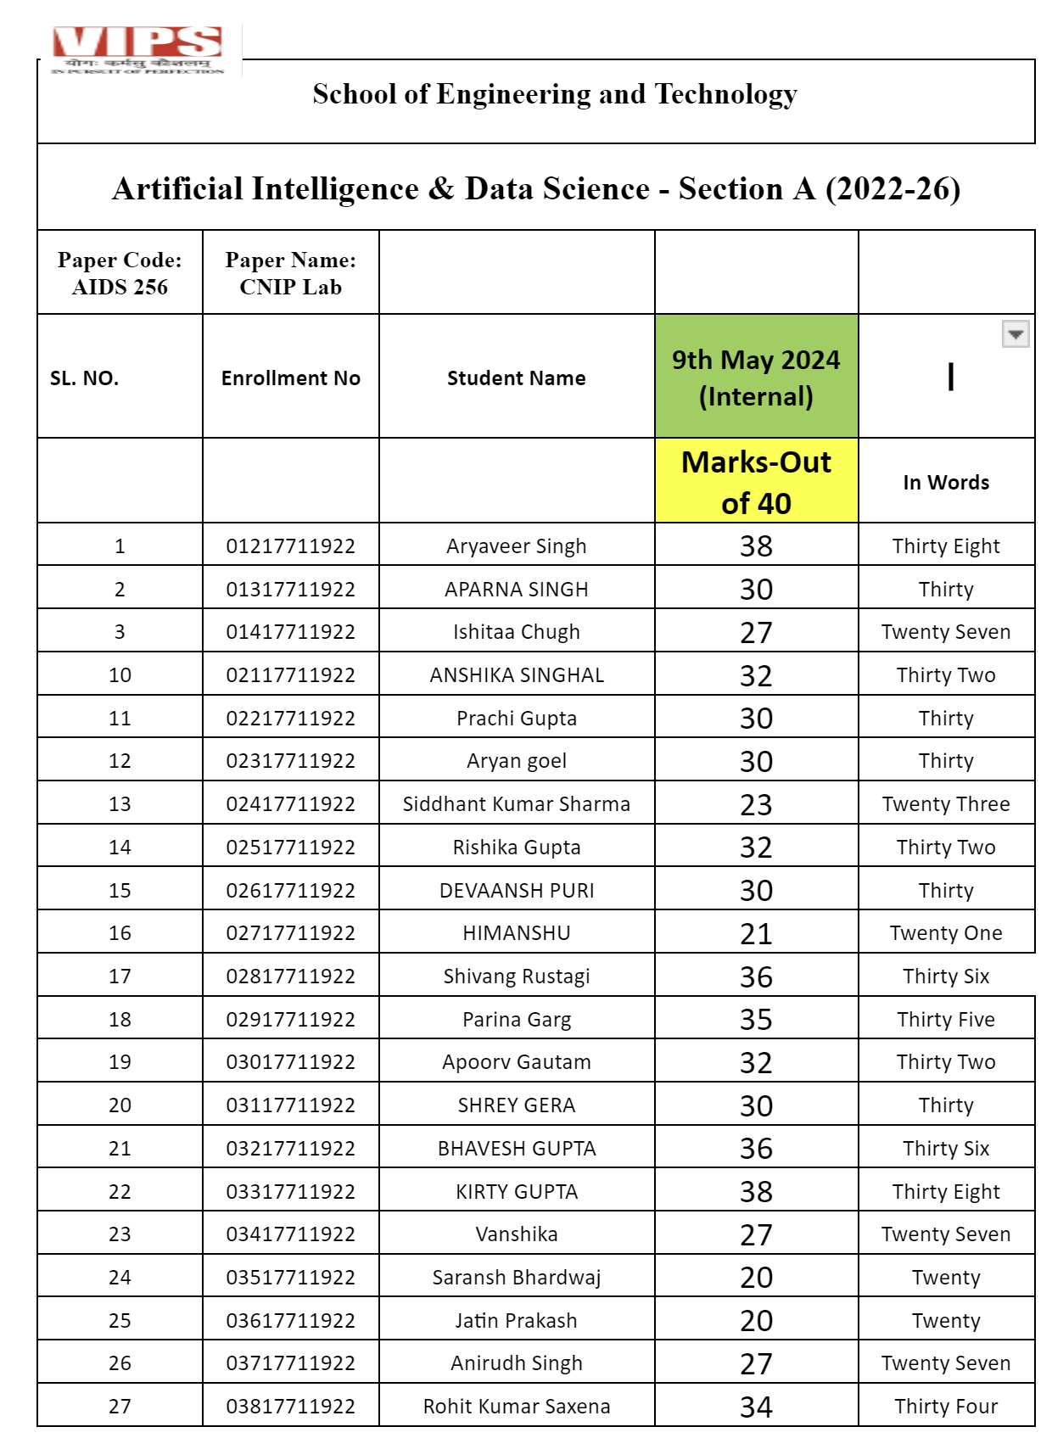

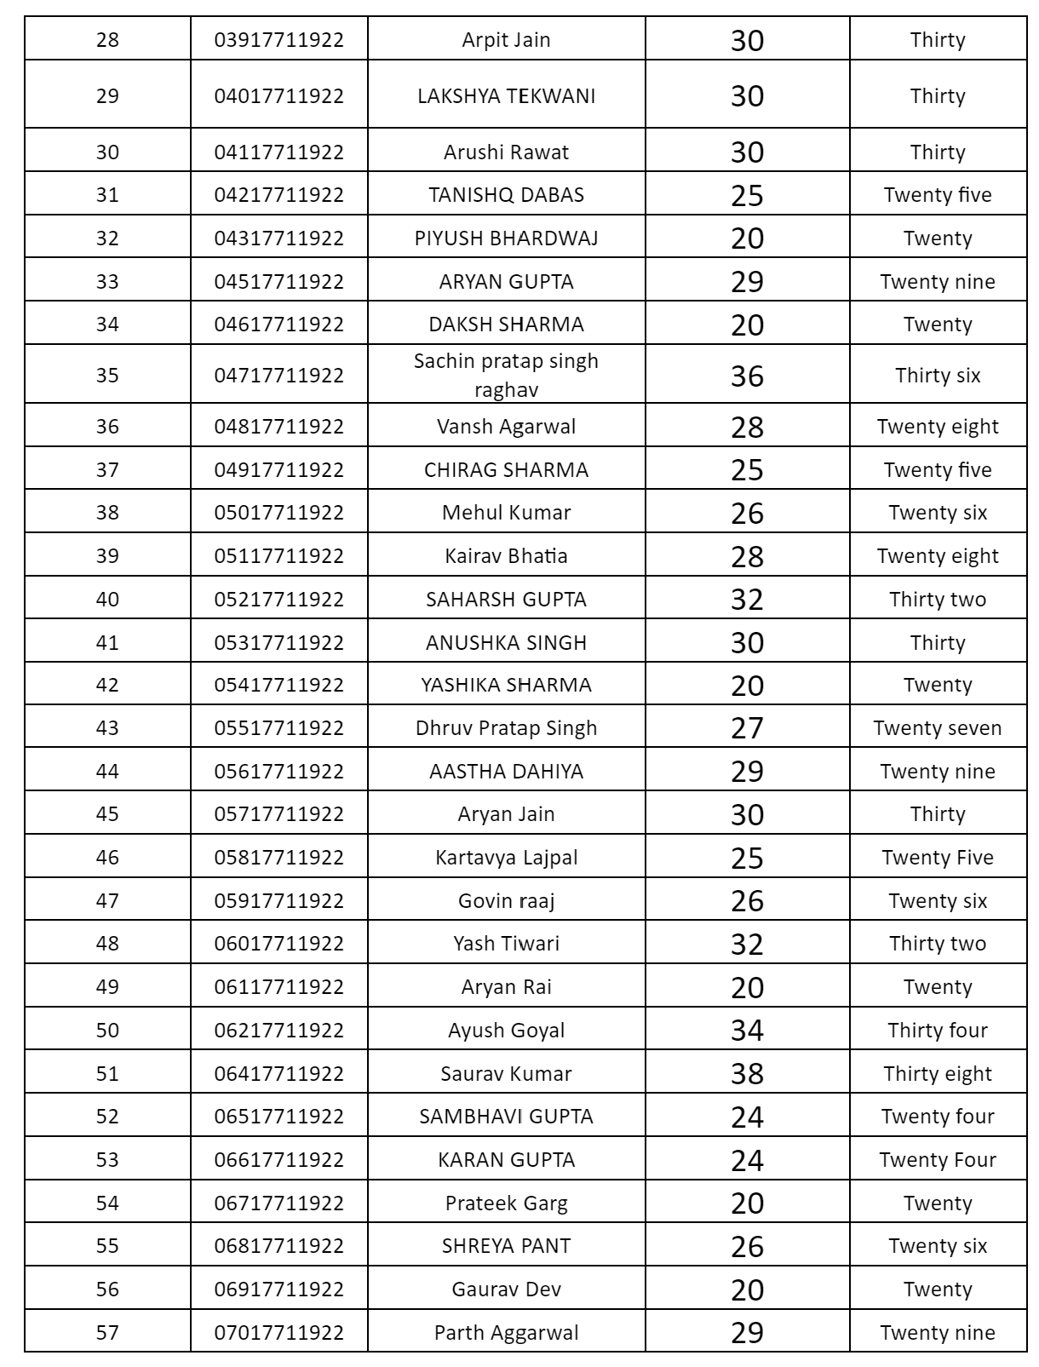

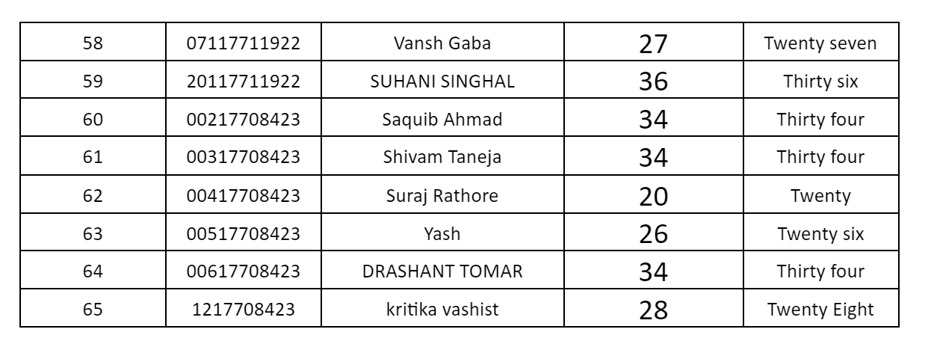

* **AIDS B**

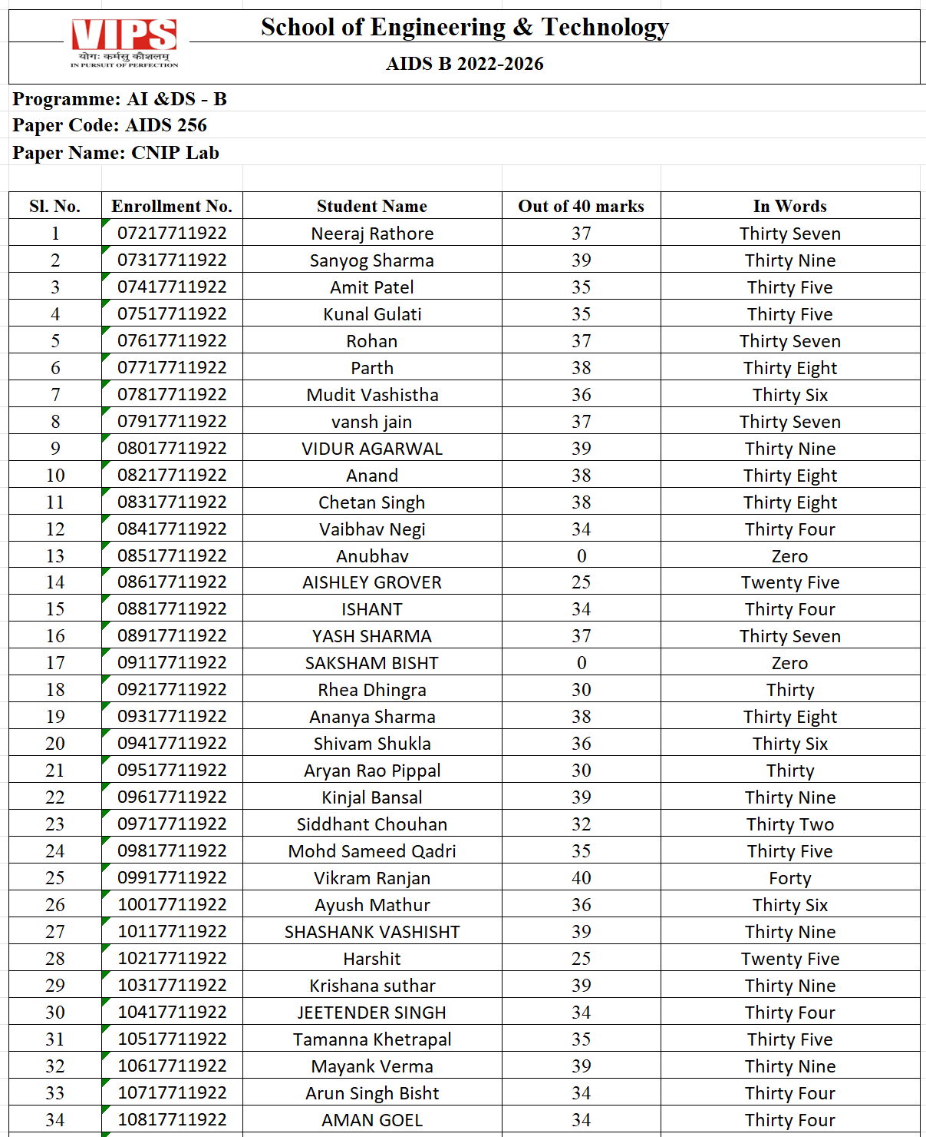

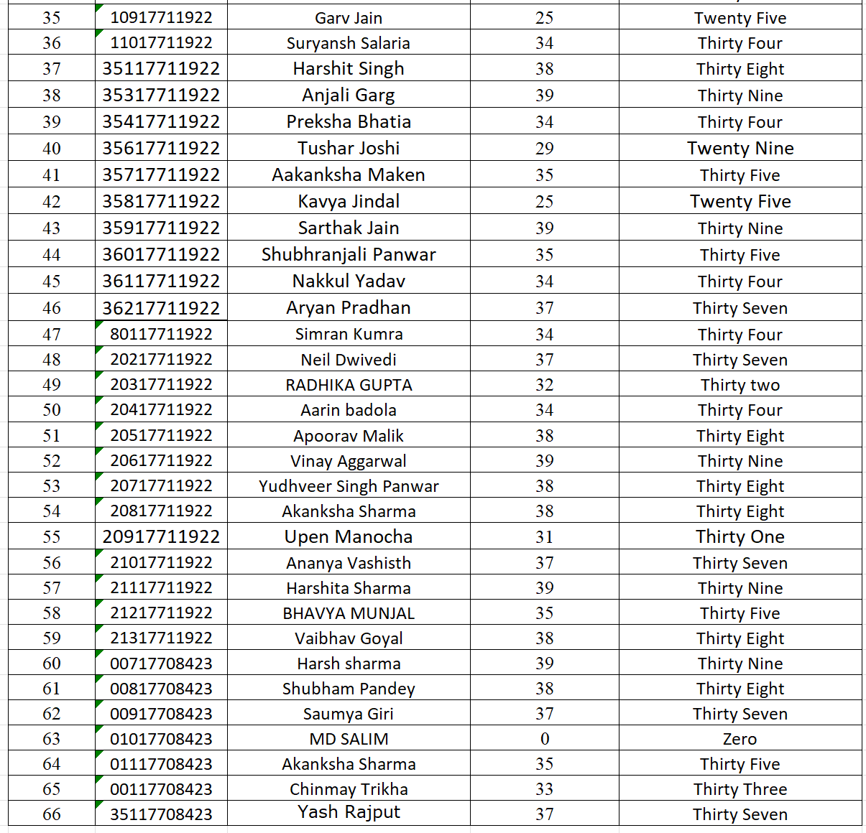

|  |  |  |  |  |
| --- | --- | --- | --- | --- |
| **S.No.** | **Enrollment No** | **Name** | **Marks of 40** | **Marks in words** |
| 1 | 00817711722 | Hemant Saini | 36 | Thirty Six |
| 2 | 00917711722 | Tanishka Nayal | 34 | Thirty Four |
| 3 | 01117711722 | LAKSHAY YADAV | 36 | Thirty Six |
| 4 | 01317711722 | Sanjay Kumar Sahu | 37 | Thirty Seven |
| 5 | 01417711722 | Uday Srivastava | 35 | Thirty Five |
| 6 | 01517711722 | VANSHIKA MAHESHWARI | 39 | Thirty Nine |
| 7 | 01617711722 | pulkit sharma | 34 | Thirty Four |
| 8 | 01817711722 | Yash Pandey | 37 | Thirty Seven |
| 9 | 01917711722 | YASH GROVER | 34 | Thirty Four |
| 10 | 02017711722 | VANSH BATRA | 25 | Twenty Five |
| 11 | 02117711722 | Shivam Nagpal | 39 | Thirty Nine |
| 12 | 02217711722 | Naveen Thakur | 33 | Thirty Three |
| 13 | 02517711722 | Vishesh Malhotra | 34 | Thirty Four |
| 14 | 02617711722 | Ayush Singh | 35 | Thirty Five |
| 15 | 02717711722 | Tanvi Khandelwal | 37 | Thirty Seven |
| 16 | 02817711722 | Hardik | 38 | Thirty Eight |
| 17 | 02917711722 | Manav Nailwal | 39 | Thirty Nine |
| 18 | 03217711722 | Satvik Mehan | 40 | Forty |
| 19 | 03417711722 | bhumik uppal | 36 | Thirty Six |
| 20 | 03617711722 | Nitin Dahiya | 34 | Thirty Four |
| 21 | 03817711722 | Sachit Roy | 37 | Thirty Seven |
| 22 | 03917711722 | Ayush Mangla | 40 | Forty |
| 23 | 04017711722 | Anurag | 31 | Thirty One |
| 24 | 04117711722 | Anshuman Kumar Singh | 34 | Thirty Four |
| 25 | 04317711722 | ANSHIKA TYAGI | 40 | Forty |
| 26 | 04417711722 | Chaitanya Tyagi | 35 | Thirty Five |
| 27 | 04617711722 | Harsh Raj | 39 | Thirty Nine |
| 28 | 04917711722 | Adarsh kumar | 31 | Thirty One |
| 29 | 05117711722 | Boudhyan Wason | 35 | Thirty Five |
| 30 | 05217711722 | SHABAN ALI | 38 | Thirty Eight |
| 31 | 05717711722 | Rohit Rathore | 27 | Twenty Seven |
| 32 | 05817711722 | Ayush Khare | 26 | Twenty Six |
| 33 | 70117711722 | Samay Dhoundiyal | 28 | Twenty Eight |
| 34 | 35217711722 | Nishant Bagga | 28 | Twenty Eight |
| 35 | 35317711722 | Lavanya Pundir | 37 | Thirty Seven |
| 36 | 35417711722 | Drishti Gulati | 39 | Thirty Nine |
| 37 | 35517711722 | Asmi Battu | 31 | Thirty One |
| 38 | 05917711722 | Aman sareen | 29 | Twenty Nine |
| 39 | 60117711723 | Arpit Gupta | 33 | Thirty Three |
| 40 | 60217711723 | ALOK JAIN | 35 | Thirty Five |
| 41 | 60317711723 | SUNNY KUMAR | 35 | Thirty Five |
| 42 | 60417711723 | Suraj Kumar Gupta | 37 | Thirty Seven |
| 43 | 60517711723 | RITESH KUMAR SARKAR | 30 | Thirty |